## Attaching Objects In Quattro:

Open the item you want to attach a photo or object to, in the example below a Location Photo is being attached to a Panel.

1. Select **View > Media Library > Upload Objects**

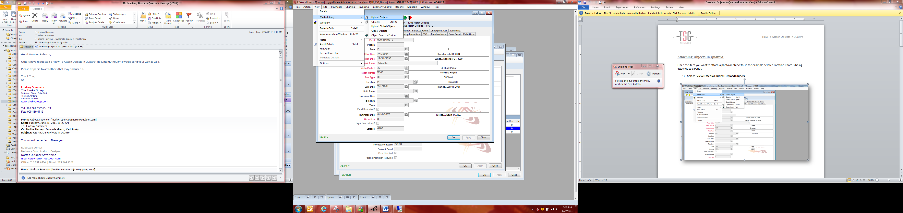

1. Which populates the ***Objects Screen*** in ***Add Mode.***

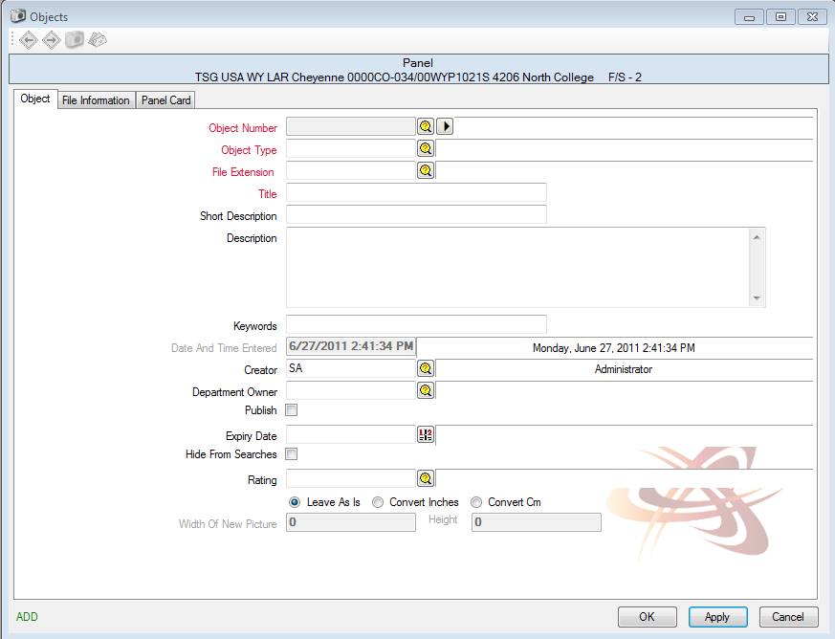

1. Enter required fields information under the ***Object Tab***

|  |  |
| --- | --- |
| **Object Number:** | Select the Browse Icon next to the field, Quattro will populate the Open Screen which will allow you to select the object you have saved to attach. |

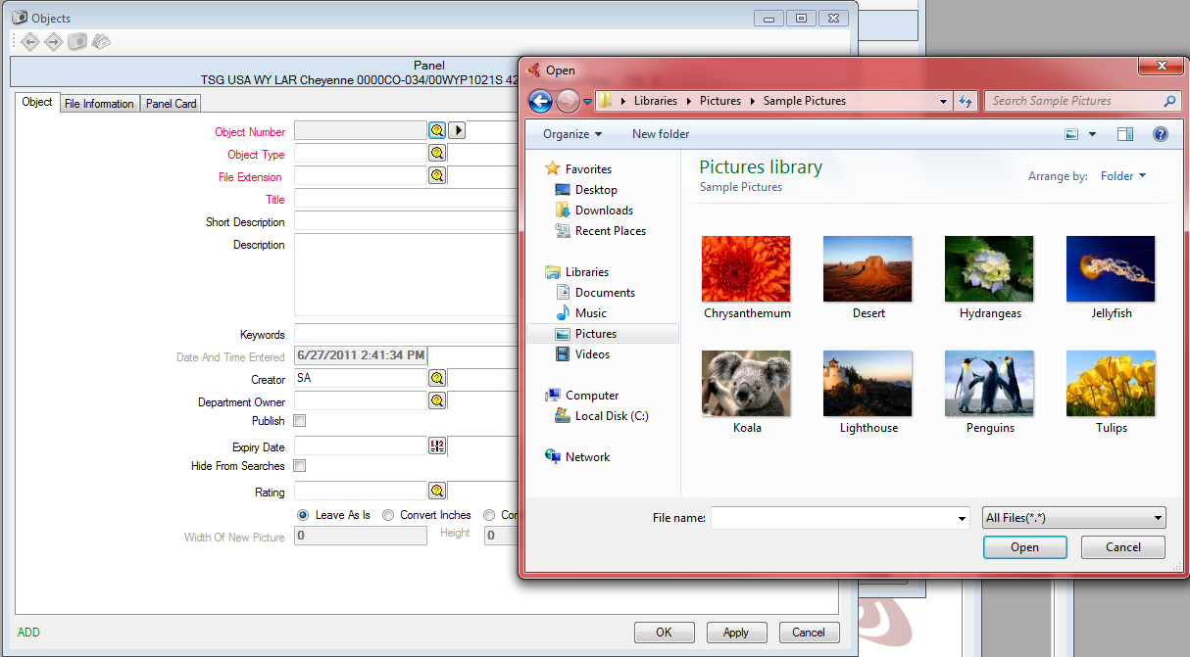

|  |  |
| --- | --- |
| **Object Type:** | Click the Browse Icon and select the appropriate Object Type, in this example Location Photo was selected. |
| **File Extension:** | Type of object that was uploaded, Quattro will automatically populate this field; JPG was populated in this example. |
| **Title:** | Text field to enter Title of object being uploaded. |
| **Short Description:** | Will automatically populate with the objects name being attached. |
| **Description:** | Text field to enter further information on the object being attached if required. |
|  |  |

1. Once all required information is filled out, ***Select Apply*** to Save.

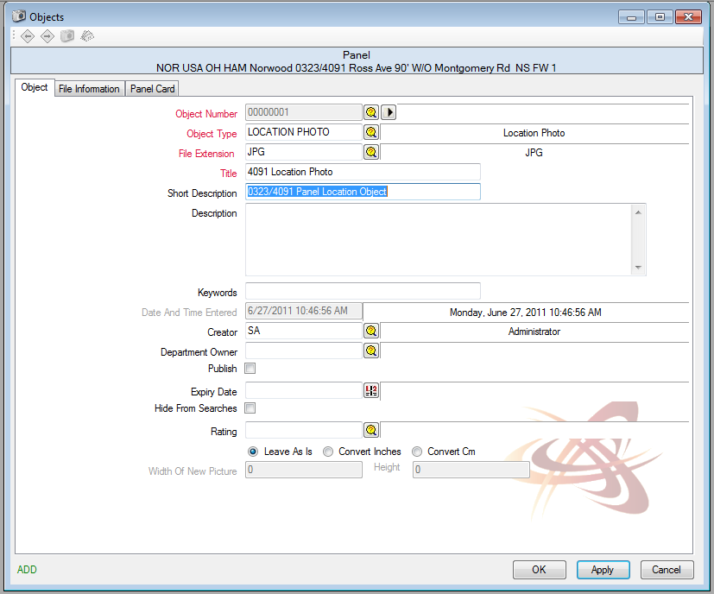

Once the object has been saved the ***Camera Icon*** will appear, which indicates that an object is attached.

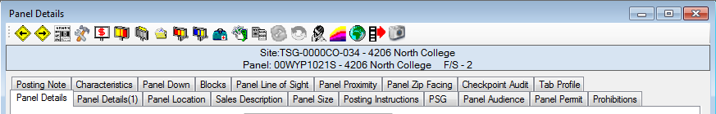

Clicking the ***Camera Icon*** will open the ***Objects attached***, if you want to see the object that is attached select the ***Play Icon***.

